From: | communication@csninc.ca
Date: | Tue, Feb 2, 2016 at 11:01 AM
Subject: | Aviva Ontario APU Part Insert Communication
Message:
Good Morning Ontario Aviva Premiere Partners,

Aviva Insurance has asked CSN Corporate to forward the email communication below outlining proper APU selection process in Audatex. The Aviva – APU Part Insert Communication is attached.

In order to ensure we are getting the best results from our APU reporting during our Pilot program, we ask that you and your staff are using the APU parts selection correctly. Attached is a diagram illustrating the process.

If you have any questions or concerns, please feel free to reach out to : APU direct at 866-599-1600 between 8 AM and 8 PM Eastern time,

Aviva Image Desk :

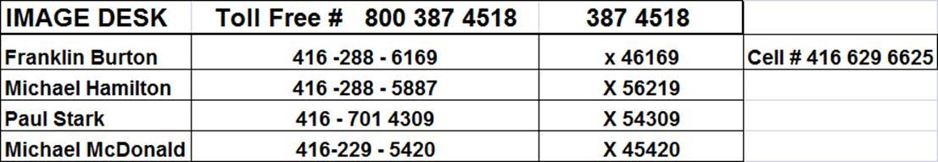

Attachment included? |  | YES

Attachment: |  | Aviva - APU Part Insert Communication - ENGLISH
Please note the following for the correct process to insert the parts selected in APU. These parts will automatically be inserted in your Audatex estimate.
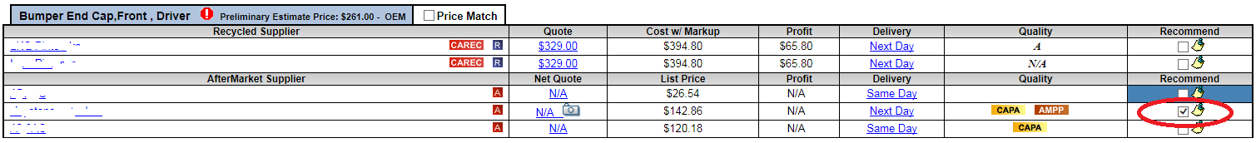
1. Once the APU search is completed and the results available, select the part (or parts) needed for your vehicle.

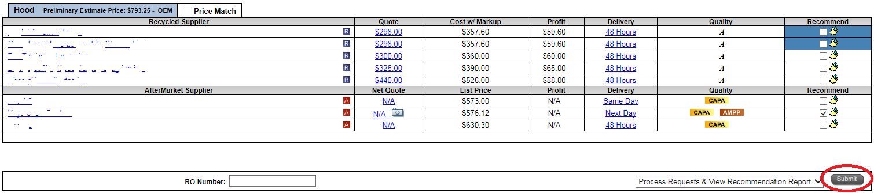
2. Confirm your choice by clicking Submit.

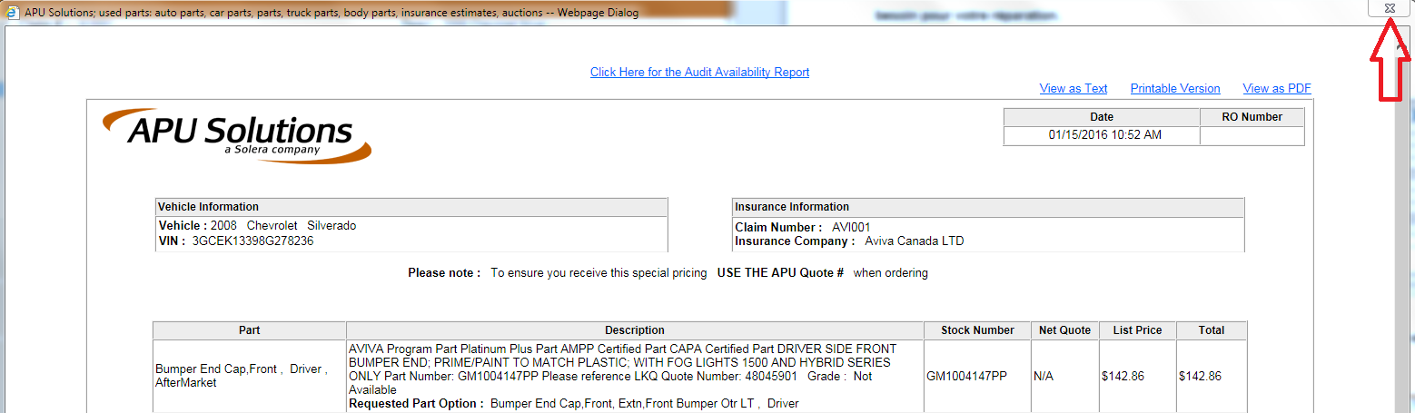
3. You can either print or save the Audit Availability Report (if applicable) and close it by clicking on the “X”.

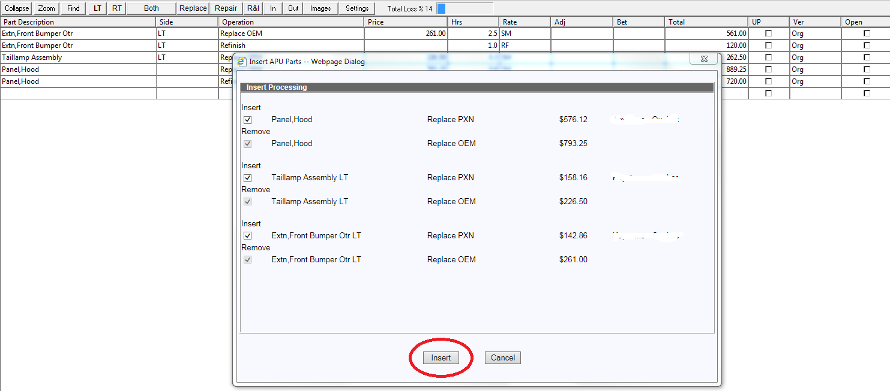
4. Wait until the Insert APU Part pane pops-up in Audatex and click on Insert.

5. The parts selected in APU will be automatically inserted in your estimate.

